Chicken Bacon Ranch Pasta
Prep time 10 minutes Cook time 25 minutes

2 Servings
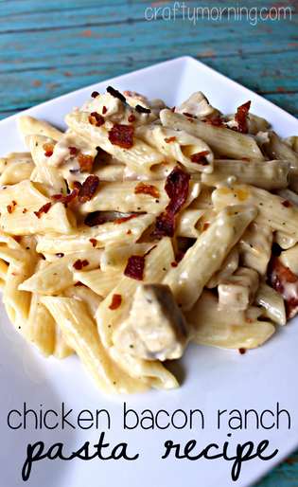
Ingredients
4 oz penne pasta
3 strips bacon
2 Tbsp flour
2 Tbsp ranch seasoning mix
½ cup heavy cream
1 Tbsp butter
Salt and pepper
2 boneless skinless chicken breasts (cut into pieces)
¼ cup shredded cheddar cheese
¼ cup shredded Monterey jack cheese

Directions
- Cook pasta according to package directions.
- Fry bacon in a skillet. Remove bacon from pan. Crumble bacon once it has cooled.
- Drain the bacon grease but keep 1 tablespoon in the pan.
- Add butter to the bacon drippings and toss in your chicken breast pieces. Cook until no longer pink.
- In a saucepan, combine the ranch dressing mix, flour and cream. Stir/whisk until it is bubbly and thick.
- Add the cheese and bacon pieces to the pan. Stir until melted.
- Combine the chicken, sauce and pasta noodles.
Notes
Substitute onion soup mix for ranch and 8 oz of sour cream for cheese
Add BBQ sauce

